Geometric Figure Dissection

Definition
# Source: AI Source: Provided by: [Data Path: Persons Table -> ID Column: 1, Name_En Column: Motasem Essam] -> From: [ChatGPT] on [7/25/2026]
Geometric Figure Dissection is the process of dividing a geometric figure into two or more smaller pieces using cuts, line segments, or curves, often so that the pieces can be rearranged to form another figure or solve a geometric problem.
Dissection is commonly used to demonstrate area relationships, solve geometric puzzles, and construct one shape from another using a finite collection of pieces.

Simple Definition
# Source: AI Source: Provided by: [Data Path: Persons Table -> ID Column: 1, Name_En Column: Motasem Essam] -> From: [ChatGPT] on [7/25/2026]
Geometric figure dissection means cutting a geometric shape into smaller geometric pieces that can be studied separately or rearranged to create another shape.
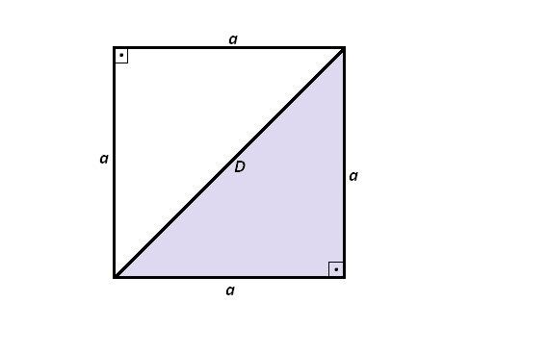
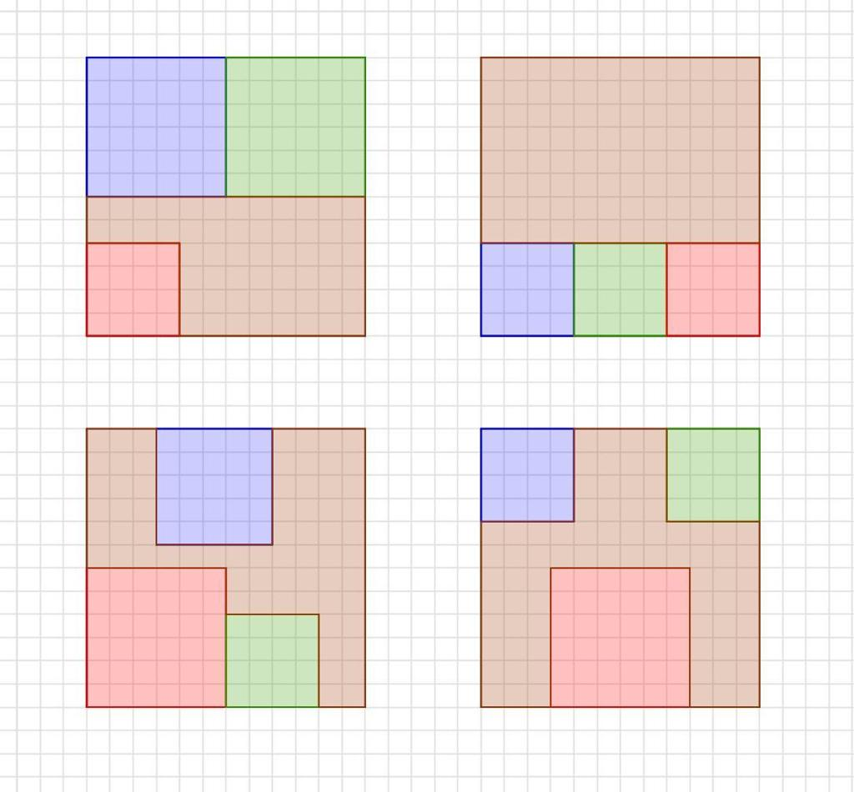
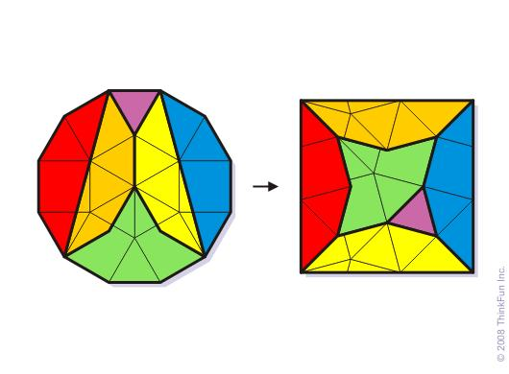

Main Classification
# Source: AI Source: Provided by: [Data Path: Persons Table -> ID Column: 1, Name_En Column: Motasem Essam] -> From: [ChatGPT] on [7/25/2026]
The following is a practical classification based on how a figure is divided. These categories are descriptive rather than a universally standardized taxonomy, and some overlap.

1. Triangular Dissection
# Source: AI Source: Provided by: [Data Path: Persons Table -> ID Column: 1, Name_En Column: Motasem Essam] -> From: [ChatGPT] on [7/25/2026]
Dividing a figure into triangular pieces.
Example: Drawing a diagonal in a square creates two congruent right triangles.
Detailed Explanation and Examples
Definition: Dividing a geometric figure into triangles.
Triangles are especially useful because their areas are easy to calculate and their properties are well studied.
Example: A rectangle $ABCD$is divided by diagonal $AC$.
The diagonal creates two triangles:
$$△ABC \text{and} △ACD$$
For a rectangle of length $8$units and width $4$units:
$$A_{\text{rectangle}}=8×4=32$$
Each triangle has half the rectangle's area:
$$A_{\text{triangle}}=\frac{1}{2}\left(8\right)\left(4\right)=16$$
Therefore,
$$32=16+16$$

2. Rectangular Dissection
# Source: AI Source: Provided by: [Data Path: Persons Table -> ID Column: 1, Name_En Column: Motasem Essam] -> From: [ChatGPT] on [7/25/2026]
Dividing a figure into rectangles.
Example: Splitting a large rectangle into four smaller rectangles.
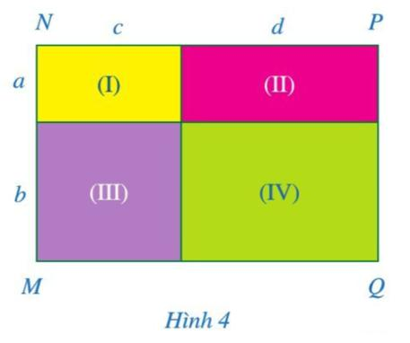
Detailed Explanation and Examples
Definition: Dividing a larger figure into smaller rectangles.
Example: A rectangle measuring $10×6$units is divided into two rectangles measuring $4×6$and $6×6$.
$$A_{\text{total}}=\left(4×6\right)+\left(6×6\right)$$
$$A_{\text{total}}=24+36=60$$
The sum of the component areas equals the original rectangle's area.

3. Grid-Based Dissection
# Source: AI Source: Provided by: [Data Path: Persons Table -> ID Column: 1, Name_En Column: Motasem Essam] -> From: [ChatGPT] on [7/25/2026]
Dividing a figure using regularly spaced horizontal and vertical cuts.
Example: Partitioning a square into nine equal smaller squares.

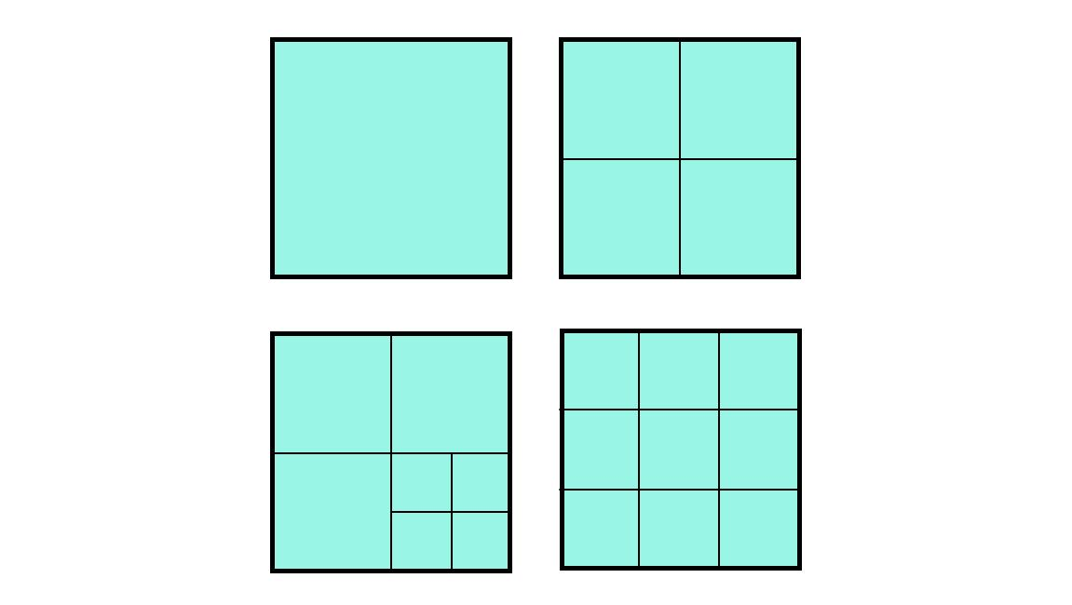
Detailed Explanation and Examples
Definition: Dividing a figure using a regular grid of line segments.
Grid-based dissection is useful for counting areas, studying fractions, and creating geometric patterns.
Example: A square of side length $6$units is divided into a $3×3$grid.
Each small square has side length $2$units, so
$$A_{\text{small}}=2^{2}=4$$
There are nine small squares:
$$A_{\text{total}}=9×4=36$$

4. Polygonal Dissection
# Source: AI Source: Provided by: [Data Path: Persons Table -> ID Column: 1, Name_En Column: Motasem Essam] -> From: [ChatGPT] on [7/25/2026]
Dividing a polygon into smaller polygons using straight cuts.
Example: Dividing a hexagon into triangles and quadrilaterals.
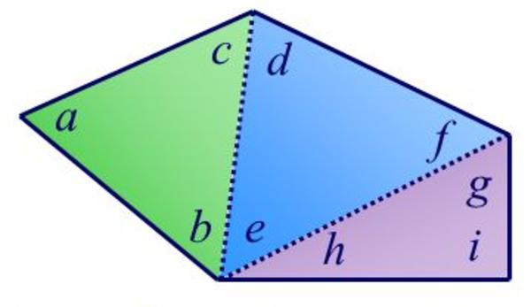
Detailed Explanation and Examples
Definition: Dividing a polygon into smaller polygons by drawing internal line segments.
A useful special case is triangulation, in which a simple polygon is divided entirely into triangles.
For a simple polygon with $n$vertices, a triangulation without additional vertices uses
$$N=n-2$$
triangles.
Example: A pentagon has five vertices, so it can be triangulated into
$$N=5-2=3$$
triangles.
This makes its area the sum of the areas of those three triangles.

5. Circular Dissection
# Source: AI Source: Provided by: [Data Path: Persons Table -> ID Column: 1, Name_En Column: Motasem Essam] -> From: [ChatGPT] on [7/25/2026]
Dividing circular regions into sectors, segments, or other pieces using radii, chords, or arcs.
Example: Dividing a circle into eight equal sectors.
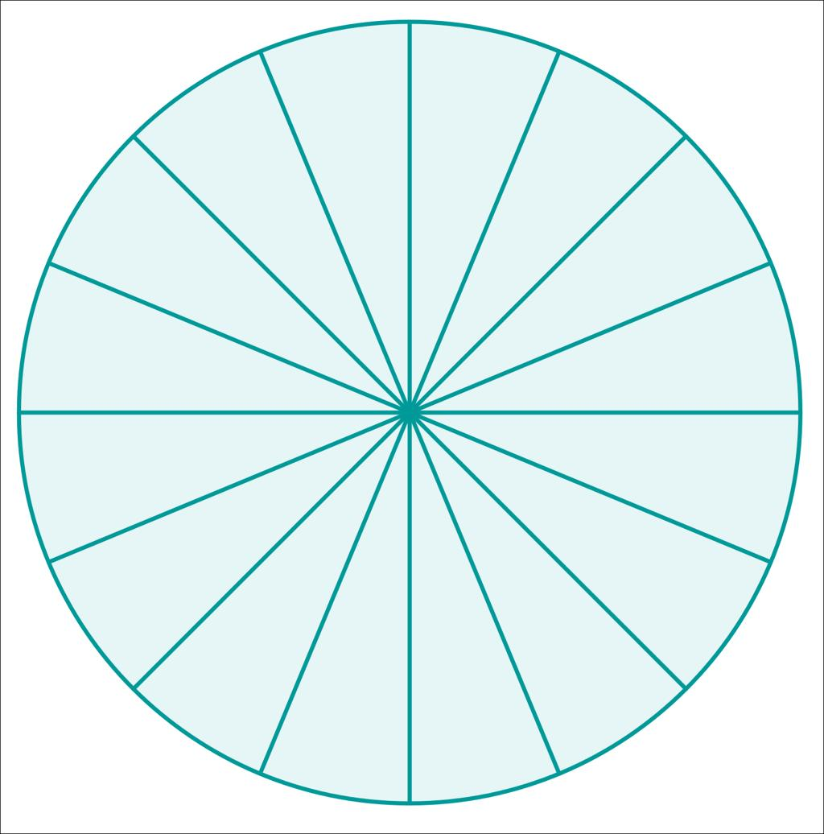
Detailed Explanation and Examples
Definition: Dividing a circular region into smaller pieces using radii, chords, or curved cuts.
Example: A circle of radius $6$ units is divided into six equal sectors. Each sector has a central angle of
$$θ=\frac{{360}^{∘}}{6}={60}^{∘}$$
The circle's total area is
$$A=π{\left(6\right)}^{2}=36π$$
Each sector has area
$$A_{\text{sector}}=\frac{36π}{6}=6π$$
square units.

6. Mixed-Shape Dissection
# Source: AI Source: Provided by: [Data Path: Persons Table -> ID Column: 1, Name_En Column: Motasem Essam] -> From: [ChatGPT] on [7/25/2026]
Dividing a composite figure into pieces of different geometric types.
Example: Separating a rectangle and a semicircle in a composite region.
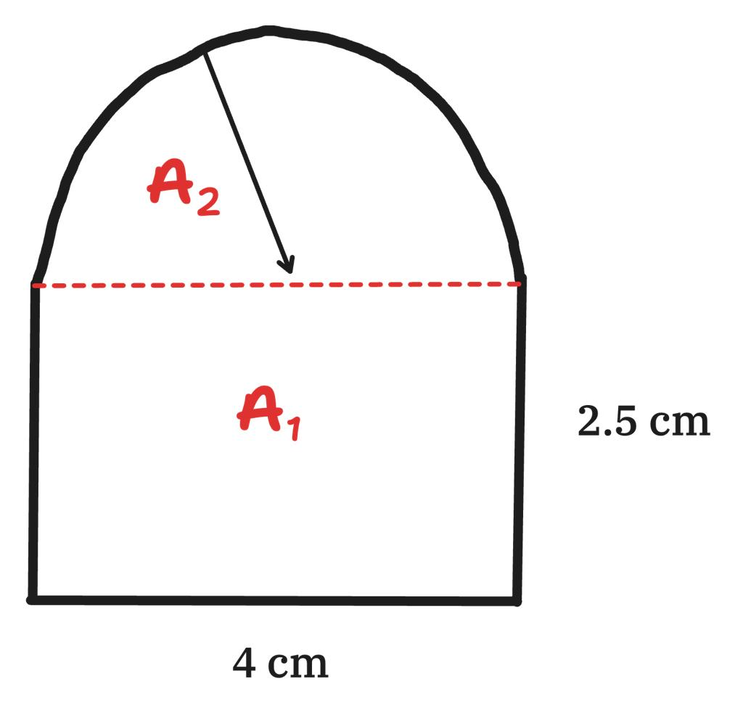
Detailed Explanation and Examples
Definition: Dividing a composite geometric figure into pieces belonging to different shape categories.
Example: A shape consists of a rectangle measuring $10×4$units and a semicircle of radius $2$units attached along one side.
If their interiors do not overlap, the total area is
$$A=10\left(4\right)+\frac{1}{2}π{\left(2\right)}^{2}$$
$$\boxed{A=40+2π}$$
square units.
Dissection makes the calculation easier by separating the rectangle from the semicircle.

7. Irregular-Piece Dissection
# Source: AI Source: Provided by: [Data Path: Persons Table -> ID Column: 1, Name_En Column: Motasem Essam] -> From: [ChatGPT] on [7/25/2026]
Dividing a figure into pieces that do not all belong to a simple standard shape category.
Example: Cutting a polygon into several irregular polygonal pieces for a puzzle.
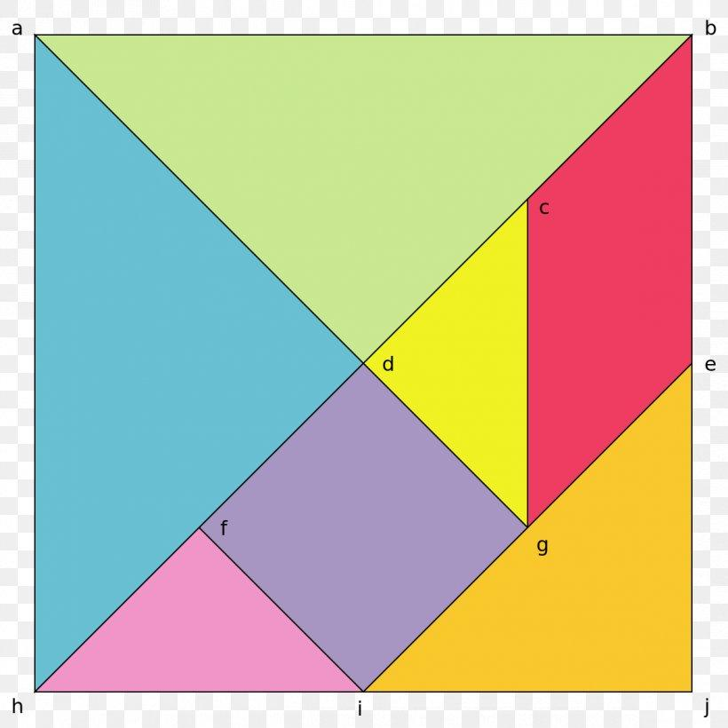
Detailed Explanation and Examples
Definition: Dividing a geometric figure into pieces that may have irregular outlines rather than familiar shapes such as rectangles or triangles.
Example: A polygon is cut into several irregular polygonal pieces. The pieces can be labeled $P_{1},P_{2},…,P_{n}$, and their areas can be added:
$$A_{\text{original}}=\sum_{i=1}^{n}{A}\left(P_{i}\right)$$
This is useful in geometric puzzles and in constructing shapes from prescribed pieces.

8. Curvilinear Dissection
# Source: AI Source: Provided by: [Data Path: Persons Table -> ID Column: 1, Name_En Column: Motasem Essam] -> From: [ChatGPT] on [7/25/2026]
Dividing a figure using curved boundaries.
Example: Dividing a circular region into pieces bounded partly by arcs.
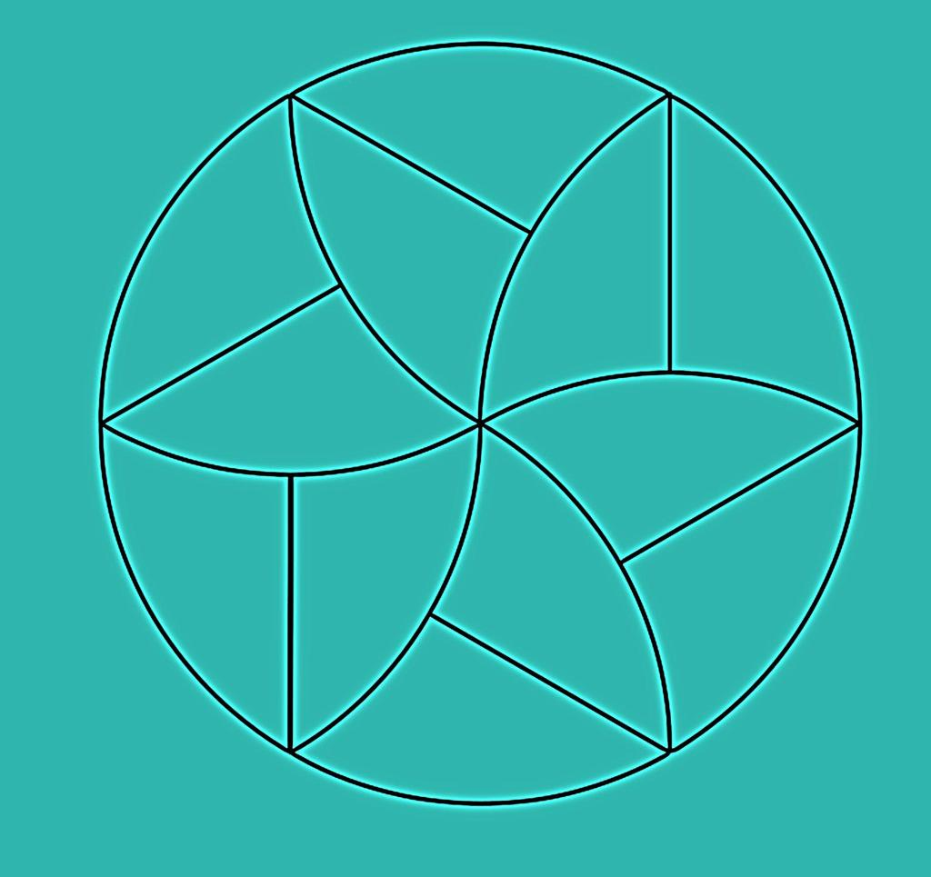
Detailed Explanation and Examples
Definition: Dividing a geometric figure into pieces with at least one curved boundary.
Example: A circular region is divided by arcs into smaller regions. The area of each piece can be calculated using sector formulas or other appropriate methods.
For a sector of radius $r$and central angle $θ$measured in radians,
$$A_{\text{sector}}=\frac{1}{2}r^{2}θ$$
The formula applies directly when the piece is a circular sector; more general curved pieces may require subtraction or integration.

9. Rearrangement-Oriented Dissection
# Source: AI Source: Provided by: [Data Path: Persons Table -> ID Column: 1, Name_En Column: Motasem Essam] -> From: [ChatGPT] on [7/25/2026]
Dividing a figure specifically to enable its pieces to be rearranged into a target shape.
Example: Cutting a polygon into pieces that can be assembled into a rectangle of equal area.
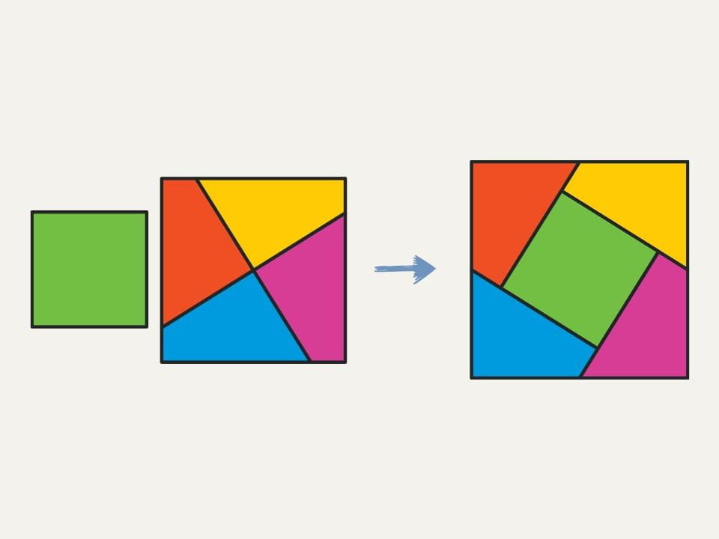
Detailed Explanation and Examples
Definition: Dividing a figure in a way that allows its pieces to form another figure under permitted movements.
Example: A square is dissected into a finite collection of polygonal pieces. Those pieces are translated, rotated, or reflected to construct a rectangle of equal area.
The key area relationship is
$$A_{\text{original}}=A_{\text{new}}$$
provided all pieces are used exactly once and fit together without gaps or overlaps.
This method is closely related to geometric dissection puzzles and visual proofs of area formulas.

Important Mathematical Principles

1. Area Additivity
# Source: AI Source: Provided by: [Data Path: Persons Table -> ID Column: 1, Name_En Column: Motasem Essam] -> From: [ChatGPT] on [7/25/2026]
If a figure is divided into non-overlapping pieces that cover it completely, then
$$\boxed{A_{\text{whole}}=\sum_{i=1}^{n}{A_{i}}}$$
This is the main principle behind area calculations by dissection.

2. Dissection and Rearrangement
# Source: AI Source: Provided by: [Data Path: Persons Table -> ID Column: 1, Name_En Column: Motasem Essam] -> From: [ChatGPT] on [7/25/2026]
Dissection and rearrangement are different operations:
- Dissection: divides a figure into pieces.
- Rearrangement: changes the positions or orientations of those pieces.
A dissection does not have to be followed by rearrangement.

3. Number of Pieces
# Source: AI Source: Provided by: [Data Path: Persons Table -> ID Column: 1, Name_En Column: Motasem Essam] -> From: [ChatGPT] on [7/25/2026]
There is no universal formula for the number of pieces in every dissection. The number depends on the original shape, the allowed cuts, and the target configuration.
For example, triangulating a simple $n$-sided polygon requires $n-2$triangles when no extra vertices are introduced.

4. Dissection Does Not Always Preserve Perimeter
# Source: AI Source: Provided by: [Data Path: Persons Table -> ID Column: 1, Name_En Column: Motasem Essam] -> From: [ChatGPT] on [7/25/2026]
Cutting a figure creates new internal boundaries. The sum of the perimeters of all pieces can be greater than the perimeter of the original figure.
Area is additive across a proper partition, but perimeter generally is not.

Geometric Figure Dissection vs Geometric Figure Decomposition
# Source: AI Source: Provided by: [Data Path: Persons Table -> ID Column: 1, Name_En Column: Motasem Essam] -> From: [ChatGPT] on [7/25/2026]
They are closely related, but not exactly identical in usage.
- Geometric Figure Decomposition is the broader concept of dividing a complex figure into simpler components for analysis, calculation, or understanding.
- Geometric Figure Dissection usually emphasizes dividing a figure into pieces, often with the intention of rearranging them to form another figure.
Comparison
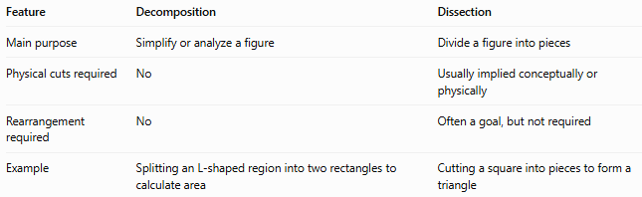
Feature | Decomposition | Dissection
Main purpose | Simplify or analyze a figure | Divide a figure into pieces
Physical cuts required | No | Usually implied conceptually or physically
Rearrangement required | No | Often a goal, but not required
Example | Splitting an L-shaped region into two rectangles to calculate area | Cutting a square into pieces to form a triangle
Relationship:
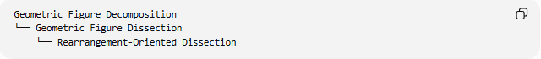
Geometric Figure Decomposition
└── Geometric Figure Dissection
└── Rearrangement-Oriented Dissection
This hierarchy is useful as a practical classification, although it is not a universally standardized taxonomy.

Geometric Figure Dissection vs. Related Concepts
# Source: AI Source: Provided by: [Data Path: Persons Table -> ID Column: 1, Name_En Column: Motasem Essam] -> From: [ChatGPT] on [7/25/2026]
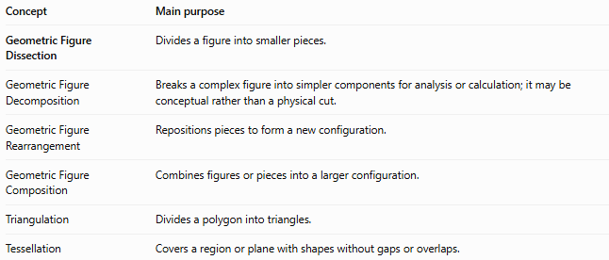
Concept | Main purpose
Geometric Figure Dissection | Divides a figure into smaller pieces.
Geometric Figure Decomposition | Breaks a complex figure into simpler components for analysis or calculation; it may be conceptual rather than a physical cut.
Geometric Figure Rearrangement | Repositions pieces to form a new configuration.
Geometric Figure Composition | Combines figures or pieces into a larger configuration.
Triangulation | Divides a polygon into triangles.
Tessellation | Covers a region or plane with shapes without gaps or overlaps.

Classification Summary
# Source: AI Source: Provided by: [Data Path: Persons Table -> ID Column: 1, Name_En Column: Motasem Essam] -> From: [ChatGPT] on [7/25/2026]
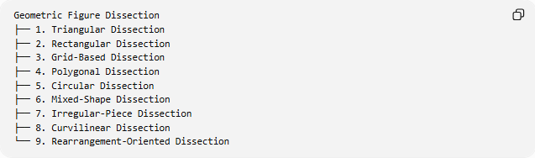
Geometric Figure Dissection
├── 1. Triangular Dissection
├── 2. Rectangular Dissection
├── 3. Grid-Based Dissection
├── 4. Polygonal Dissection
├── 5. Circular Dissection
├── 6. Mixed-Shape Dissection
├── 7. Irregular-Piece Dissection
├── 8. Curvilinear Dissection
└── 9. Rearrangement-Oriented Dissection
These categories describe different approaches to dissection; they are not mutually exclusive. For example, a rearrangement-oriented dissection may also be triangular and polygonal.

Key Points
# Source: AI Source: Provided by: [Data Path: Persons Table -> ID Column: 1, Name_En Column: Motasem Essam] -> From: [ChatGPT] on [7/25/2026]
- Dissection divides one figure into two or more pieces.
- Cuts may be straight or curved.
- Pieces can be familiar shapes or irregular shapes.
- Dissection is useful for area calculations, geometric proofs, and puzzles.
- Area additivity requires a complete partition without overlapping interiors.
- Rearrangement is a possible next step, not a necessary part of dissection.

Conclusion
# Source: AI Source: Provided by: [Data Path: Persons Table -> ID Column: 1, Name_En Column: Motasem Essam] -> From: [ChatGPT] on [7/25/2026]
Geometric Figure Dissection is a technique for dividing geometric figures into smaller pieces to simplify calculations, reveal mathematical relationships, or prepare the pieces for rearrangement. It connects naturally to triangulation, area decomposition, geometric puzzles, and visual proofs.

